**Month of the Military Child**

**APRIL 2025**

**Ways for Service families to get involved…​**



**This document contains some ideas for Service families to consider participating in during the Month of the Military Child.**

The SSCE Cymru team will be working with education settings and local authorities across Wales to carry out activities during this month to understand, raise awareness and celebrate the unique experiences this group of children and young people have, and become a more Armed Forces-friendly environment.

April is designated as the Month of the Military Child, which highlights the important role Service children play in the Armed Forces community. It is a time to applaud Armed Forces families and their children for the daily sacrifices they make and the challenges they overcome.

**Purple Up Day**

**Wednesday 30th of April is the day to 'Purple up' for Month of the Military Child in Wales!**



**Why purple?**Purple was chosen because it symbolizes all branches of the military, a combination of Army Green, Air Force Blue, Coast Guard Blue, Marine Red and Navy Blue.

**How can you get involved?**

* Wear purple
* Create purple artwork and displays
* Take photos of what you get up to
* Share your photo/s on social media (tag @SSCECyrmu on [X](https://twitter.com/SSCECymru) and [Facebook](https://www.facebook.com/people/SSCE-Cymru/100085033424658/)) using the hashtag #MotMCCymru
* Send your photos to [SSCECymru@wlga.gov.uk](mailto:SSCECymru@wlga.gov.uk).

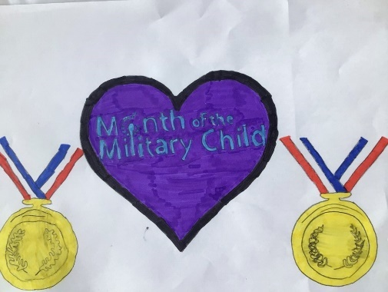

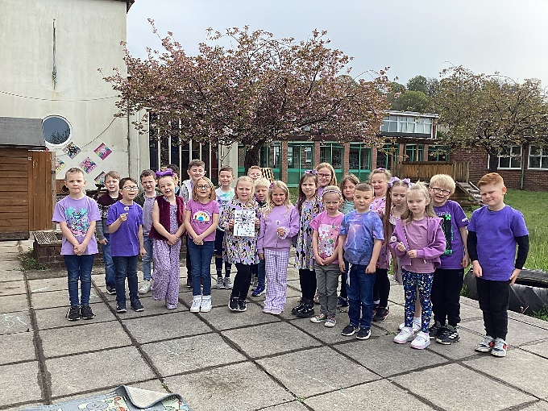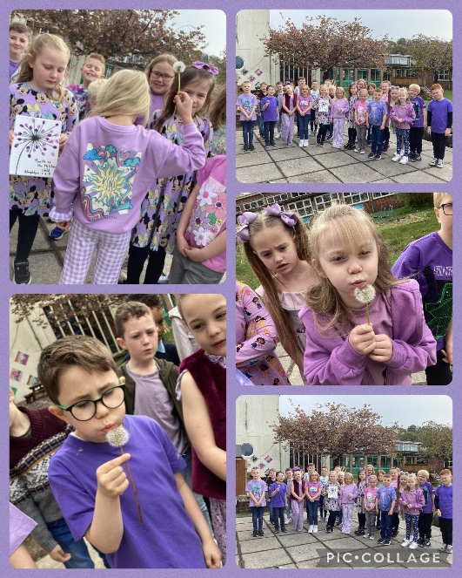

Support children in entering the Reading Force Memoir Writing Competition. Open 1 May – 31 August.

Support children in entering the Never Such Innocence [Poetry and Art Competition](https://www.neversuchinnocence.com/month-of-the-military-child). Open 1 April - 2 May.

[Sing Dandelions](https://drive.google.com/drive/folders/13Hv7LvI6dsRbUHWZNPmS-k4ytnRWVtZJ?usp=drive_link) by Never Such Innocence. Music video, backing track and sheet music available.

Make bunting and posters and use purple balloons to decorate your home.

Encourage your children to get creative and produce a piece of artwork that showcases their experiences of being part of an Armed Forces family.

Complete Armed Forces-themed activity sheets, puzzles and wordsearches, available from [Little Troopers](https://www.littletroopers.net/little-troopers-at-school/resources-for-schools/).

Create purple and dandelion themed artwork.

Celebrate Purple Up day on Wednesday 30th April.

Create a display to celebrate Month of the Military Child using purple handprints.

**Service children’s experiences**

**CELEBRATE**

Help Service children to learn about the role of their Service parent, create a story together of your family on an adventure and share it with your family and friends.

Speak to your child’s school about ways they could get involved with Month of the Military child.​

Offer tweens and teens the *Life of a Page Turner Reading Journal*, a personal journal in which military young people can express their thoughts and feelings in words and drawings. Available through [Reading Force](http://www.readingforce.org.uk/).

Conduct fundraising activities and donate the proceeds to a local or national Armed Forces charity.

Support Service children in writing a thank you card to someone who helped them or was a good friend to them when they arrived in the area.