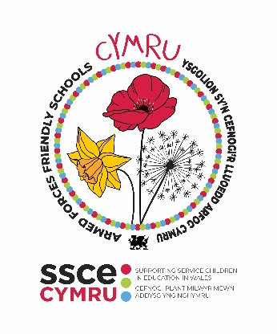

**Armed Forces Friendly Schools Cymru – audit form**

**GOLD STATUS**

**AIMS:**

1. **EMBED a good practice for supporting Service children**
2. **CREATE a positive environment for Service children to share their experiences**
3. **ENCOURAGE schools to become more engaged with the Armed Forces Community.**

**SCHOOL DETAILS**

|  |  |
| --- | --- |
| **School name** |  |
| **Contact name** |  |
| **Job title** |  |
| **Email address** |  |
| **Local Authority** |  |
| **Number of Service children on roll** |  |

|  |
| --- |
| How has your school benefited from working towards the Armed Forces Friendly School’s Cymru **GOLD** status?  ***maximum 200 words*** |
|  |

**COMPULSORY CRITERIA**

|  |  |  |  |  |
| --- | --- | --- | --- | --- |
| **Item** | **Evidence/ Details required** | | | |
| **Have previously been awarded Bronze and Silver Armed Forces Friendly School Cymru status** | Date Bronze awarded:  Date Silver awarded: | | | |
| **Celebrate Month of the Military Child (April)** | Date and Event that took place: | | | |
| Please share feedback from Service children and staff involved in the events | | | |
| Service child(ren) |  | | |
| School Staff |  | | |
| **Embed a process for listening to your Service children and creating opportunities for them to share their experiences.** | Please share details on the processes that you have embedded within your school. | | | |
|  | | | |
| **Implement actions identified through the SCiP Alliance Thriving Lives Toolkit to progress to the “developing” or “embedding” status for all 7 principles** | *Please share details of how implementing actions, identified in the Thriving Lives Toolkit, has helped your school to develop provision for Service children.* | | | |
|  | | | |
| *Please complete the below table to indicate the school’s current position for each principle.* | | | |
| **Principle:** | | **Developing** | **Embedding** |
| Our approach is clear | | /6 | /6 |
| Wellbeing is supported | | /5 | /5 |
| Achievement is maximised | | /6 | /6 |
| Transition is effective | | /6 | /6 |
| Children are heard | | /5 | /5 |
| Parents are engaged | | /5 | /5 |
| Staff are well informed | | /5 | /5 |
| **Complete at least 80% of the activities/ actions on the school checklist.**  *83 items required for Gold* | Section of checklist | | | No. of items per section |
| Armed Forces in Wales | | | /22 |
| Service children’s experiences | | | /19 |
| Education in Wales | | | /16 |
| Service children's data and school admissions | | | /11 |
| Mental health and wellbeing | | | /11 |
| Extra-curricular activities | | | /12 |
| Funding | | | /7 |
| Research and Evidence | | | /9 |
| **TOTAL** | | | /107 |

**SUPPORTING DOCUMENTS CHECKLIST**

|  |  |
| --- | --- |
| **Supporting document** | **Attached** |
| Tool 1. SSCE Cymru Checklist: School actions and activities | ☐ |
| [SCiP Alliance Thriving Lives Toolkit](https://www.scipalliance.org/thriving-lives-toolkit) **–** completed self-assessment | ☐ |
| Armed Forces Friendly Schools Cymru Silver status certificate | ☐ |
| Armed Forces Friendly Schools Cymru Bronze status certificate | ☐ |

**Form submitted by (name):**

**Sign (digital):**

**Date:**

**WHAT NEXT**

* Once completed, please send to [SSCECymru@wlga.gov.uk](mailto:SSCECymru@wlga.gov.uk) along with all supporting documents indicated above
* Your audit will be reviewed within one month of submission
* You will receive an email confirming the outcome of your audit submission, along with relevant Armed Forces Friendly Schools (AFFS) Cymru logos that can be used on your school website and email signatures
* Your schools' details will be added to the SSCE Cymru website to indicate you have been awarded Gold AFFS Cymru status
* Co-ordinate local/regional opportunities to celebrate your school's success in achieving Gold status
* Your school can continue to work with the SSCE Cymru team in supporting Service children within your school.