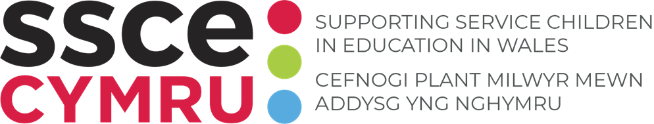
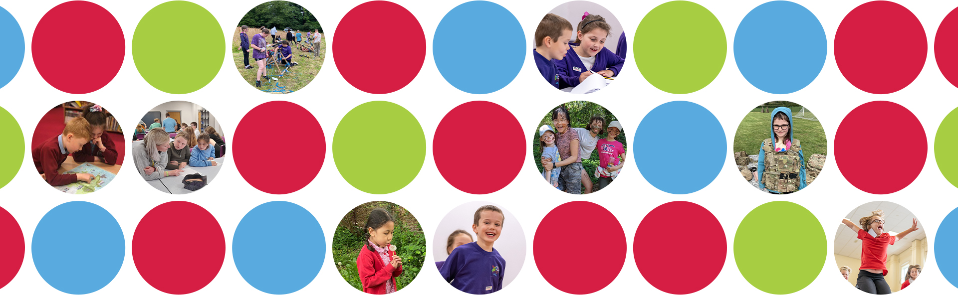
SSCE Cymru Service Pupil Promise Event Plan

A structured approach to gathering Service children’s voices enabling the creation of a Local Authority Service Pupils’ Promise

Overview:
The following workshop has the aim of gathering the views of Service children in a Local Authority area of Wales, getting the pupils to reflect on how their schools support and celebrate them whilst also identifying what more could be done to improve that support, particularly around times of school transition and parental deployment. It is hoped that the outcomes will feed into the creation of a Local Authority Service Pupils’ Promise (see suggestions at the end of this document). The definition of Service children should be that adopted by the Service Children’s Progression (SCiP) Alliance, thereby incorporating children of veterans.

Key question: ‘Should schools treat Service children any differently to other pupils, and if so, why and how?’
The answer to this will be determined through exploring the following:
- What are the advantages and disadvantages of being a ‘Service child’?
- What do schools do well to celebrate and support their Service children?
- What would the ideal learning/school experience be like to ensure all Service children are successful and happy in school?
- What are the main issues/challenges for Service children in schools and how can they be overcome?

Organisational points:
- Target participants - KS2 & KS3 Service children (depending on maturity, older KS1 pupils might also benefit). A roving microphone helps.
- It works best having mixed-age, mixed-school groups of 4-8 children table, each with a facilitator – ideally circular tables.
- A large space with the ability to project onto a large screen – non-school venue, preferable (e.g. large seminar room / community centre).
- Ensure all facilitators are well briefed – they should be fully aware of the aims, encouraged to support and not to provide leading answers.
- Table facilitators should not be the children’s own staff member. It is best to use another adult, a staff member from another school or a KS4/5 student – experience suggests that with the former, children are more likely to give the answers they think their staff want to hear.
- Having refreshments on arrival and name badges adds to a ‘conference’ feel to the workshop – pupils typically respond with maturity.
- Having a military VIP to say a few words at the beginning or end of the workshop adds to its perceived importance.
- Some of the following activities can be removed if the session length is less than three hours long.
- Perhaps have the accompanying school staff seated together but separate from the pupils, allowing them to observe and / or receive some CPD – possible activities for adults in blue text below.

Guide timings | Grouping | Session | Activity theme | Resources
 |  |  | Schools arrive / refreshments / signing in  Pupils seated in mixed-school tables with each child having at least one peer from same school with him / her. | Refreshments / name badges
10-20 mins | In table groups on arrival -  pupils and adults | 1/ Settler activity  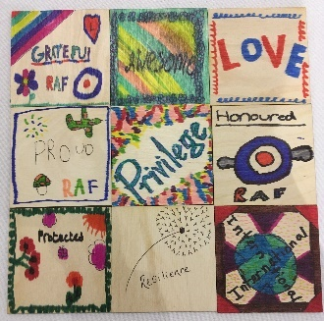   | OPTION 1: Mosaic tile creation  What are you most proud about being linked to the military?  - Each child to draw an image on a 3 x 3-inch wooden square depicting this and add one word to summarise it  - Each child to explain to the facilitator why they have chosen what they have – and share with table group  (The tiles can then be used to create a collage / mosaic, possibly using an outline shape. Whilst cardboard tiles can be used, the benefit of wooden tiles is that they are hardier and can be glued. If a child makes a mistake, the tiles can be turned over for a fresh start.)  OPTION 2: Friendship bracelet making  - Each child to choose their beads to make a bracelet, perhaps for the Month of the Military Child or for a special person.  - Ask a friend or adult if help is needed tying it at the end.  - If for a gift, children to write on it their first name and branch of the military their parent/guardian is in.  NB. This activity can be continued throughout the workshop | Projector/screen/laptop  Wooden squares  Coloured Sharpie pens  Friendship bracelet resources – beads
20 mins | Whole group | 2/ Welcome &  setting the scene & Icebreaker | Welcome to whole group  Introduction of schools  Table introductions – name, year group, link to the Armed Forces  Overview and aims of the day / clarify ‘Service child’ definition  Complete ‘Find a Friend’ bingo | Projector/screen/laptop
15 mins | Table groups | 3/ Hearing Service children’s views | OPTION 1: NSI Winner A Soldier’s Call Poem  Introduce the poem. The Poem ‘A Soldier’s Call’ was written by Evie-Sue, a Service child living in North Wales. The Poem was one of the winners of the Never Such Innocence Month of the Military Child competition 2025. Read the poem and in your groups discuss;  - What is the poem about?  - Are any of the experiences similar to your own?  - What positive and negative experiences of Service children does this poem cover?  OPTION 2: Listening to others  Watch a couple of short videos from SSCE website  SSCE Cymru :: Service children film and discuss / reflect.  OPTION 3: Dandelion Poem  Adults to read the Dandelion Poem – a line from each adult spread across the room is particularly powerful. Pupils discuss this – do they agree with it? | Projector/screen/laptop  Print outs of A Soldier’s Call poem for annotation  Internet access and speakers  Films; SSCE Cymru :: Service children film  Print outs of Dandelion poem for annotation
20 mins  30mins | Table groups | 4/ Pros and cons  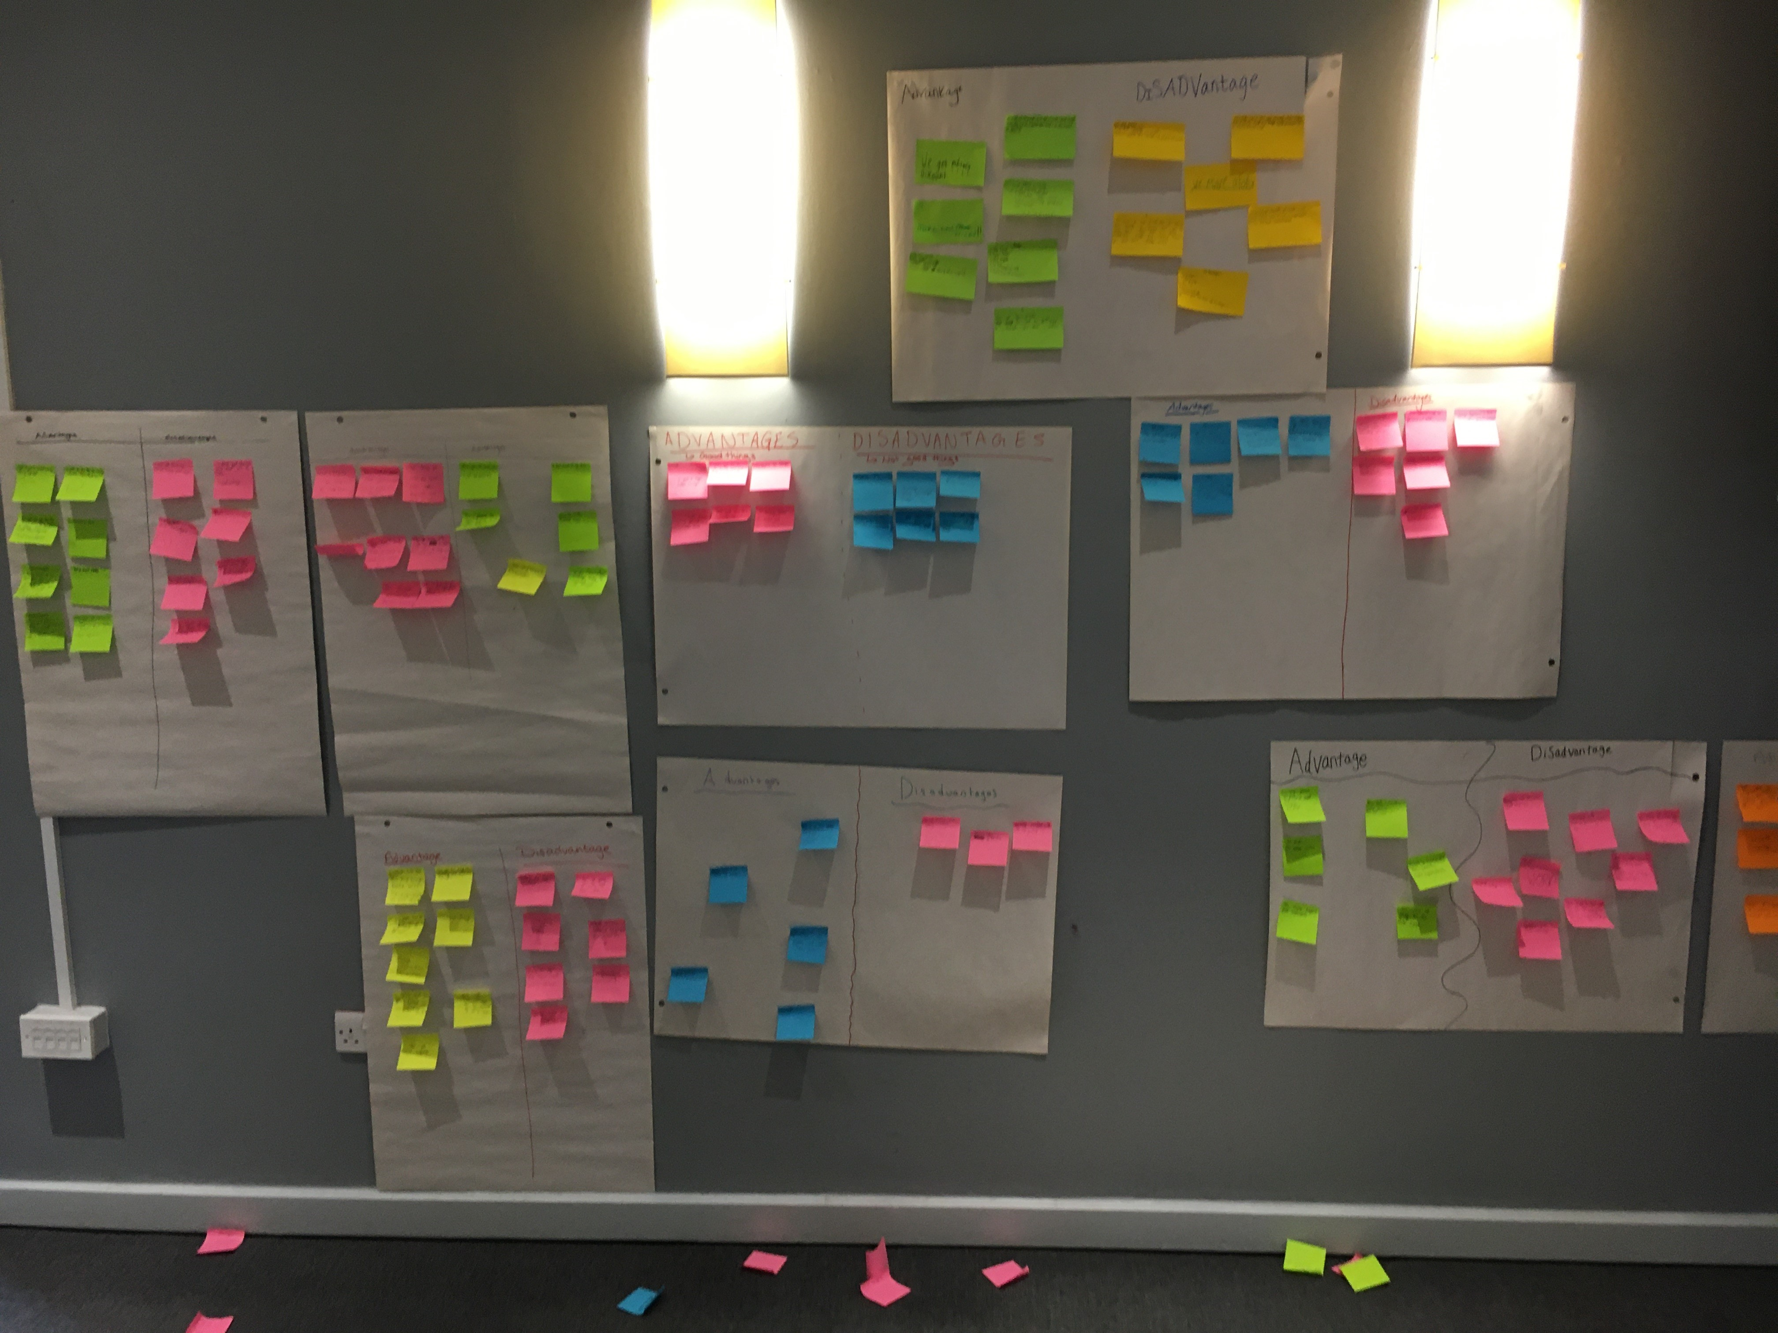 | PUPILS: What are the advantages and disadvantages of being a ‘Service child’?  ACTIVITY 1:  Vote with your feet (movement activity) linked to advantages and disadvantages.  What branch of the Armed Forces is your Armed Forces family member in? Royal Navy, Army, RAF  What is your connection to the Armed Forces? Currently Serving, Veteran, Reservist.  Which of these experiences are you most drawn to? 1. Separation – Weekending, 2. Separation – Operational Tour, 3. Separation – Exercise / courses, 4. Moving – new house/new school, 5. Post-Service (Remembrance, Forever home, young carer/PTSD/Medical)  Why? What are/were the advantages and challenges of this/these experience/s?  Ask a select number of SC to share.  Is there anyone else who can relate to this?  ACTIVITY 2: -  Think, pair, share on tables  2 colours of Post-It notes / pens to record as many advantages and disadvantages as you can.  Each table, supported by facilitator, to choose the 3 most important advantages and 3 most significant disadvantages.  Stick these on the large sheets for display at front (or on the board).  Discuss similarities / differences between the groups.  Example sheets available for facilitators and/or SC if required. If you completed the pre activity you could reflect on 4 and 5.  ADULTS: What are the advantages and disadvantages of having Service children in your school?  Think, pair share - 2 coloured Post-Its for recording | Post-Its – 1 pack of each colour per table  Advantage / Disadvantage handout for mind map  Large Flip Chart sheets of paper on wall divided into advantages and disadvantages  Prompts for staff- see prompt cards  Example / template Pros cards  Example / template Cons cards  (examples taken from Pembrokeshire SC pre events)
15 mins | Table groups | 5/ Celebrating success | PUPILS: What does your current school do well, or what did previous schools do well, to celebrate your Service child experiences / lives and to support you as a Service child?  Discuss with a partner / small group & then share ideas with table.  Facilitator to record on a big sheet or paper divided into 2: celebrate/support. Blu-tac up for all to see.  Elicit further information e.g. if SC mention SC clubs then find out what they do in the clubs, why they like them etc. If SC mention MotMC celebrations find out what their schools have done to celebrate this.  ADULTS: What are the barriers that you have experienced with your Service children? Why are these barriers? | Big sheets to write on and pens  Large sheet of paper on wall divided into celebrate / support
30-60 mins based on activities included | Table groups | 6/ Identifying and  Overcoming challenges  (If short of time, this activity can be omitted and discussed as part of the next activity) | PUPILS: What are the main barriers/challenges for Service children in school?  List these on Post-it notes / create a mind map – detailing any barriers and challenges. Service children can link these to the disadvantages earlier activity. Display on a central board You may find it helpful to use different colour pens for each barrier / challenge. (10 mins)  Each table group is then allocated a different issue / challenge:  What could schools do to help overcome this barrier/challenge?  - Large sheet of paper per table. Children record all ideas as a spider diagram (10 mins)  - Rotate around tables a couple of times so others can add additional ideas/solutions (10 mins)  ADDITIONAL ACTIVITIES  You may wish to include addition activities here eliciting the Service children’s involvement in creating materials/resources to help overcome the identified barriers/challenges. These could be linked to common barriers/challenges e.g.  - Lack of Understanding  - Separation  - Moving, settling and forever  Or barriers/challenges and identified earlier.  OPTION 1: Big Empathy Drawings  Big Empathy Drawings can be used to explore underlying emotional themes/core feelings through drawing. More information can be found here.  Display example big empathy drawing/s on the board. Explain what a big empathy drawing is linking to the example drawing/s commenting on how the person who created this drawing might have felt. (It is beneficial to have a facilitator with their own experience talk about their own big empathy drawing here or how they think a Service child may feel at these times).  Individual Service children create a big empathy drawing of their own (or annotate the examples provided) based on a key challenge they have experienced as a Service child e.g.  Separation – weekending, deployment, exercise, from other family/friends  Moving, settling and forever – the unknown, new home, school, location, friends, when will it happen  Veteran – what is a veteran, ‘being military connected, how does it make you feel, PTSD  OPTION 2: Assembly  Plan an Assembly to be delivered in schools to explain what life is like as Service child. This assembly should help address lack of understanding as well as cover challenges such as separation, moving etc.  You could consider using content from SSCE Cymru Tool 11. TEMPLATE: Service children experience presentation  OPTION 3: Video  Record video clips of Service children reflecting on life as a Service child. All previous activities could be reflected upon e.g. pros and cons, school successes, barriers and challenges.  ADULTS: Questions for discussion:  How are school leaders using the Thriving Lives Toolkit to review Service children provision?  Are barriers identified and tailored support used to overcome them? What is working? | Post-it notes  Central big sheet  Large sheets of paper and pens  Different coloured pens for each table  Example Big Empathy Drawings  Large sheets of paper  Different coloured pens
20-30 mins | School groups | 7/ Improving provision  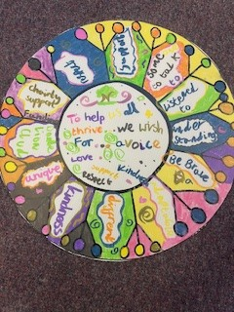  NB Older pupils could create a pledge for others such as the Council, MOD and the Welsh Government (or all three combined!) | Creating a group (or school) pledge  Each group’s staff member leads a discussion with his / her group of Service pupils reflecting on the learning from the whole workshop.  Consider the following questions:  - How can our school support Service children even more during times of parental separation?  - How can our school support Service children moving into or leaving the school even more than it currently does?  - How can our school make sure that Service children’s unique identities are recognised and celebrated?  - Any other things you think our school should do to support SC?  From this discussion, create a group (or school) pledge. Write down your pledge. Separately record ideas for fulfilling it.  This could be presented in different ways e.g.  - Dandelion (pledge in centre, ideas for fulfilling pledge and petals  - Giant hands  - Tree and leaves  - Shield  - Scroll / Charter  Work collaboratively to add finishing touches / doodles / decorations using bright colours, designs and symbols to represent the group’s identity.  Example of a school pledge (Primary)  Example of a school pledge (Secondary) | White Correx / cardboard dandelion flower template per school / colouring pens / pens
10 mins | All together | 8/ Plenary / reflections | OPTION 1:  Answer one of the workshop’s big questions:  ‘Should schools treat Service children any different to other pupils?’  OPTION 2:  Complete a version of ‘I wish my teacher knew.’  I wish my ...(examples below) knew ...  (insert teacher, friend, lunch supervisor, Mum, Dad etc)  This could be completed simply e.g. on a post-it note or in a more creative way e.g. bauble, luggage tag, post-card, wish stick  OPTION 3:  Postcard request:  If option 3 above was not done, it could be done now.  Feedback form – as desired  ADDITIONAL ACTIVITIES  There may be other big questions that arise during the event. You may wish to include these here. | Roving microphone  e.g. bauble, luggage tag, post-card, wish stick  Postcard template  Pupil feedback form  A suitable prize / coin

Service Children Promise – guidance to Local Authorities

An opportunity for any Local Authority following a Service children’s ‘voice’ event, is being able to create a Promise or Pledge that both it and its schools can then ‘sign up’ to and publicise. By doing so, all will be visibly demonstrating their commitment to the Armed Forces Covenant’s duty of due regard (2022). Examples from Oxfordshire (2020) and Rutland (2022) County Pembrokeshire (2025), Bridgend (2026) and Neath Port Talbot (2026) Councils are included in the resources accompanying this plan. Both are also published on these Councils’ websites. At the time of writing, North Yorkshire Council is close to publishing its version.

What should a Promise include?

It is recommended that the document is kept short, but that it includes the following sections:
- A brief context (e.g. how did the Promise come about / which military institutions are sited in the local area, etc)
- A summary of the Armed Forces Covenant and what its legal duty is
- A summary of the things that Service children say would help them at school (these should come out of the Voice event)
- What schools and settings will aim to do to mitigate disadvantage to any Service children on their rolls
- What the Local Authority commits to do, especially at policy level, to mitigate disadvantage. Senior officer ‘sign-off’ being key.

A template for adaptation is included in the accompanying resources.

