**Armed Forces Day 2025**

**Saturday 28th June**

**Armed Forces Day is a chance to show your support for the men and women who make up the Armed Forces community: from currently serving troops to Service families, veterans and cadets.**

Armed Forces Day in Wales commemorates and celebrates the Armed Forces community and is a partnership event between local authorities, Welsh Government, the tri services and other partners. Each year, Wales' Armed Forces Day is hosted and celebrated in a different region across the Country.

**This year Monmouthshire will be hosting the celebrations!**

**Artwork theme:** ‘What the Armed Forces means to you’.

**To get involved:**

* Download and print the template below
* Have fun designing your jigsaw piece
* Cut out the template
* Return in the post to the address provided.

Don’t forget to share on social media tagging @SSCECymru and @MonmouthshireCC

Monmouthshire County Council are inviting Service children and their peers across Wales to get involved by designing a jigsaw piece which will be displayed as one collective piece of art at the Caldicot Castle and Country Park.

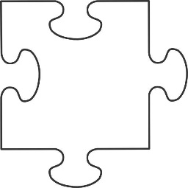



**RETURN BY:**

**8th June 2025**

**NOTE: Monmouthshire schools can expect to receive wooden jigsaw pieces from the local authority.**

**POST TO:**

The Armed Forces Team

Monmouthshire County Council

County Hall

United Kingdom

NP15 1GA

