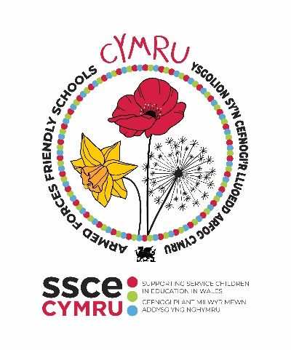

**AIMS**

1. **EMBED good practice for supporting Service children**
2. **CREATE a positive environment for Service children to share their experiences**
3. **ENCOURAGE schools to become more engaged with the Armed Forces Community.**

**SCHOOL DETAILS**

|  |  |
| --- | --- |
| **School name** |  |
| **Contact name** |  |
| **Job title** |  |
| **Email address** |  |
| **Local authority** |  |
| **Number of Service children on roll** |  |

|  |
| --- |
| How has your school benefited from working towards the Armed Forces Friendly Schools Cymru **Silver** status?  ***Maximum 200 words*** |
|  |

**COMPULSORY CRITERIA**

|  |  |  |  |  |  |
| --- | --- | --- | --- | --- | --- |
| **Item** | **Evidence / details required** | | | | |
| **Have previously been awarded a Bronze Armed Forces Friendly School Cymru status** | Date Bronze awarded: Click or tap to enter a date. | | | | |
| **Organise for a member of the Armed Forces to deliver a session with Service children and their peers ~~the Armed Forces Engagement teams to deliver a session with Service children and their peers~~** | *Please share feedback from Service children and staff involved in the activities.* | | | | |
| Date session took place: Click or tap to enter a date. | | | | |
| Service child(ren) |  | | | |
| School staff |  | | | |
| **Liaise with the SSCE Cymru Participation Lead Officer to explore options for listening to Service children** | *Please share details about how you plan on listening to Service children in your school.* | | | | |
|  | | | | |
| **Completed the SCiP Alliance Thriving Lives Toolkit, providing a self-assessment of the school's support for Service children in all 7 principles** | *Please share information about how completing the self-assessment has helped your school to understand your provision and identify development opportunities.* | | | | |
|  | | | | |
| *Please complete the below table to indicate the school’s current position for each principle.* | | | | |
| **Principle:** | | **Emerging** | **Developing** | **Embedding** |
| 1. Our approach is clear | | /6 | /6 | /6 |
| 1. Wellbeing is supported | | /5 | /5 | /5 |
| 1. Achievement is maximised | | /6 | /6 | /6 |
| 1. Transition is effective | | /6 | /6 | /6 |
| 1. Children are heard | | /5 | /5 | /5 |
| 1. Parents are engaged | | /5 | /5 | /5 |
| 1. Staff are well informed | | /5 | /5 | /5 |
| **Complete at least 60% of activities/actions on the school checklist**  *62 items required for Silver* | **Section of checklist** | | | | **No. of items per section** |
| Armed Forces in Wales | | | | /22 |
| Service children’s experiences | | | | /19 |
| Education in Wales | | | | /16 |
| Service children data and school admissions | | | | /11 |
| Mental health and wellbeing | | | | /11 |
| Extra-curricular activities | | | | /12 |
| Funding | | | | /7 |
| Research and Evidence | | | | /9 |
| **TOTAL** | | | | **/107** |

**SUPPORTING DOCUMENTS CHECKLIST**

|  |  |
| --- | --- |
| **Supporting document** | **Attached** |
| Tool 1. SSCE Cymru Checklist: School actions and activities |  |
| [SCiP Alliance Thriving Lives Toolkit](https://www.scipalliance.org/thriving-lives-toolkit) **–** completed self-assessment |  |
| Bronze Armed Forces Friendly Schools Cymru status certificate |  |

**Form submitted by (name):**

**Sign (digital):**

**Date:** Click or tap to enter a date.

***NOTE: Silver ‘Armed Forces Friendly Schools Cymru’ status will be valid for two years from the date this audit is submitted once approved by the SSCE Cymru team.***

**WHAT NEXT**

* Once complete, please send to [SSCECymru@wlga.gov.uk](mailto:SSCECymru@wlga.gov.uk) along with all supporting documents indicated above
* Your audit will be reviewed within one month of submission
* You will receive an email confirming the outcome of your audit submission, along with relevant Armed Forces Friendly Schools (AFFS) Cymru logos that can be used on your school website and email signatures
* Your schools’ details will be added to the SSCE Cymru website to indicate you have been awards Silver AFFS Cymru status
* Coordinate local/regional opportunities to celebrate your school’s success in achieving Silver status
* Your school can continue to work with the SSCE Cymru team to achieve Gold AFFS Cymru status.