

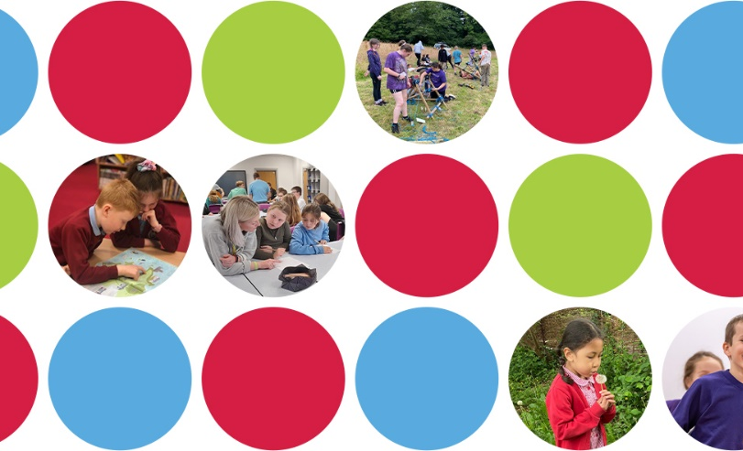

SSCE Cymru Service Pupil Promise
Pre-event activity

A structured discussion with a group of Service children

This question-set has been designed as an optional pre-event for schools to use ahead of an LA-wide Service Children Voice workshop. It may be of particular help to schools with larger Service children cohorts, allowing the outcomes to be taken to such an LA event by a school’s ‘Service Children’s Ambassadors’ or some representative pupils. The template can also be useful to any school leader who wishes to explore Service children’s views, and is designed with KS2 & 3 pupils in mind.

Questions to discuss with a group of Service children

- Have you heard the phrase ‘Service child’ before? Who does it refer to, and why ‘Service’?

- Do you think being a Service child is any different to being a civilian child? Why?

- Are you proud of having a parent who is, or was, in the Armed Forces? Why do you say this?

- What do you consider are the best bits of being part of a military family?

- What do you consider are the worst bits of being part of a military family?

- Does your school give you any additional support because you are Service children? If yes, what? (Consider support when parent/s are away from home due to work e.g. weekending or deployment. Consider support when arriving or leaving a school).

- Do you think most adults in our school understand what it’s like to be a Service child?

- Do you have any ideas for providing even better support to our school’s Service children?

Additional question for Secondary-aged pupils

- Are there any things you think the MOD or the Government should change to help Service children in their education?

Guidance to school staff / facilitators

How you undertake this pupil voice session will depend on a number of factors, in particular the number of Service children in the group, their age and how much time you have.

At the simplest level, a group of 6-8 children can sit around a table with an adult facilitator who then leads a discussion on the questions he/she wishes to ask, bullet-pointing a summary of answers given (perhaps also including any direct quotes that stand out). This would need about 30 minutes. Having two facilitators can help with the smooth-running of the session, allowing one adult to lead the discussion and the other to be the scribe. If only one adult is available, recording the session might help ensure all key points are captured.

To add more interaction, especially if you have a little more time, the following could be considered:
- Some of the questions lend themselves well to the use of large Post-it notes, for example questions 4 and 5 (which could be answered together using green and red Post-its).
- Some questions could be done using a scoring system of some sort. For example, each child could have five cards numbered 1 to 5, and for questions such as Q3 and Q7, they could first discuss these in pairs and then decide on a how strong a response to give (e.g. 1 = strongly disagree, up to 5 = strongly agree).
- For younger children, some questions could have pictorial responses created either individually or in pairs. For example, for Q1 they could draw their view of a Service child and label it; or for Q8 they could sketch things they think the school could provide or do for them which they would find helpful.
- Some of the questions could also be written on large sheets of paper, with each sheet placed on a different table. The whole group of children could then be split into smaller groups of 2-3, which then rotate around the tables reading and building on the responses given by previous pupils.

The Jigsaw teaching strategy method

For larger groups, especially of older pupils, a ‘jigsaw’ pedagogical approach could be adopted. The jigsaw method of teaching is a collection of topics, or questions, which will be fully developed by pupils before coming together to make a complete idea. This type of cooperative learning strategy allows individuals or small groups to become responsible for a subcategory of a larger topic (in this case, different questions of the pupil voice activity). After developing their idea, each individual or small group then has the responsibility to teach or share it to the rest of the group or class.

Jigsaw within groups

First, the facilitator divides the larger group into smaller groups. Each member of the smaller groups consider just one or two questions, with the ten questions allocated to different members of each smaller group. Using this approach, each of the smaller groups would collectively work on all the questions. Once individuals have considered their allocated question(s), they can then meet with individuals from the other small groups who have considered the same question(s) to better develop their answers and become ‘experts’. Each pupil then returns to his/her original group and shares the answers to the rest of their group. This approach works well for pupils who are learning to work with a group but who may not yet be comfortable speaking in front of a larger group.

