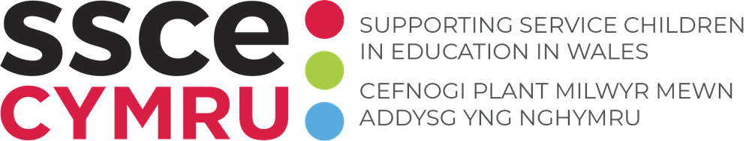

TEMPLATES: Data collection
Data on Service children is not formally collected in Wales. To support this unique group of learners it is important to identify where they are.

How to use this tool:
Use your preferred combination of templates below to survey parents/carers to conduct a data collection exercise to identify Service children within your school, to be shared with SSCE Cymru annually.
- Template 1: Communication template – message for email / app communication.
- Template 2: Communication template – detailed letter.
- Template 3: Survey template – questions and multiple-choice responses for electronic survey.
- Template 4: Survey template – paper return form.

Instructions:
- Consider which templates are appropriate to support with your data collection process e.g. communication via app (Template 1) with link to electronic survey (Template 3).
- Edit the text identified in red italics.
- Send communication to parents/carers and collect responses.
- Submit data to SSCE Cymru annually using the data collection form linked here.

Template 1: Communication template - message for email / app communication
Consider using the template below to electronically communicate the data collection process with parents/carers.

To effectively support our Service children at add name of school and strengthen add local authority name Council’s commitment to the Armed Forces Covenant Duty, we hope to identify Service children attending our school.
Please help us to gain an understanding of our Service community by completing and submitting this form by add return date. Annually, we share the total number of Service children enrolled at our school with SSCE Cymru. In line with GDPR guidelines, all names and identifying characteristics of children will remain confidential.

Template 2: Communication template - detailed letter
Consider using the template below to communicate the data collection process with parents/carers via email, email attachment or paper.

SUBJECT: Supporting Service children in education
Dear Parent/carer,
At school name, we are committed to understanding the needs of all our learners and supporting them with their experiences throughout education. One such group that we aim to support is Service children (children of Armed Forces personnel).
Our school recognises that the Service child may need support with their learning, settling into new situations and/or mental health and wellbeing, as a result of their unique circumstances. This could be linked to mobility, deployment, separation and/or resettlement.
To effectively support our Service children and strengthen local authority name Council’s commitment to the Armed Forces Covenant Duty, we hope to identify our Service children at school name. By identifying the number of Service children in our school, we can be proactive in understanding their needs, making support available and accessing funding if required. We can also work with SSCE Cymru further to develop our provision for Service children.
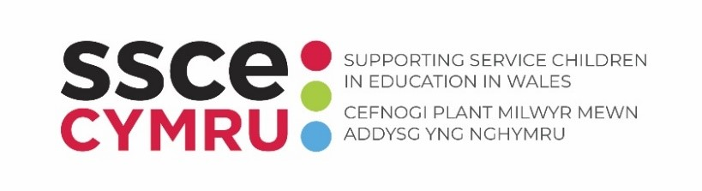
The SSCE Cymru mission is to provide the best possible educational support to Service children in Wales. SSCE Cymru works collaboratively with organisations across the UK to build an evidence base that impacts policy and systems. SSCE Cymru also provides a suite of resources to support education professionals and Service families across Wales, this includes:
- SSCE Cymru e-learning package
- Good practice examples
- School toolkit and tools
- Service family guide
- Directory of support
- Armed Forces Friendly Schools Cymru
- Funding guidance
SSCE Cymru work with schools that have identified Service children, to develop knowledge, embed good practice and support access to relevant grant funding and training opportunities.
For further information, visit www.SSCECymru.co.uk

Please help us to gain an understanding of our Service community by completing the below form and returning it to the school by add return date. Annually, we share the total number of Service children enrolled at our school with SSCE Cymru. In line with GDPR guidelines, all names and identifying characteristics of children will remain confidential.
Kind regards,
Name
Job title

Template 3: Survey template - questions and multiple-choice responses for electronic survey
Consider using the template below to create your own electronic survey e.g. google forms, Microsoft forms. Send out the link or QR code to parents/carers for completion.

Title | Service children data collection year
Form description | Please help us to gain an understanding of our Service community by completing and submitting this form by add return date. Annually, we share the total number of Service children enrolled at our school with SSCE Cymru. In line with GDPR guidelines, all names and identifying characteristics of children will remain confidential.  For the purpose of this survey we will be using the Welsh Governments definition of a Service child:  A Service child is a child whose parent(s) or carer(s) with parental responsibility who:  • Currently serves in the HM Regular or Reserve Armed Forces – Royal Navy or Royal Marines, British Army, or Royal Air Force,  • Previously served in the Armed Forces and left within the past six years,  • Died while serving in the Armed Forces, and the child receives a pension under the Armed Forces Compensation Scheme or the War Pensions Scheme.
Question number | Question | Response
Question 1: | Childs name | Text answer
Question 2: | Childs year group | Text answer
Question 3: | Does your child/ren fit within the Welsh Government definition of a Service child?  Welsh Governments definition of a Service child:  A Service child is a child whose parent(s) or carer(s) with parental responsibility who:  • Currently serves in the HM Regular or Reserve Armed Forces – Royal Navy or Royal Marines, British Army, or Royal Air Force,  • Previously served in the Armed Forces and left within the past six years,  • Died while serving in the Armed Forces, and the child receives a pension under the Armed Forces Compensation Scheme or the War Pensions Scheme. | (Multiple choice)  Yes  No
Question 4: | Which Service are your family connected to? | (Multiple choice)  Royal Navy / Royal Marines  British Army  Royal Air Force (RAF)  N/A
Question 5: | In what way are your family affiliated to this service? | (Multiple choice)  Regular  Reservist  Veterans / ex-Service personnel  N/A
Question 6: | We are also keen to identify and support children who do not fit within the Welsh Government definition of a Service child but have a link to the Armed Forces. Would your child fall within this category? | (Multiple choice)  Yes  No

Template 4: Survey template – paper return form
Consider using the template below to send out a paper survey to parents/carers for completion.

Service children data collection year
Please help us to gain an understanding of our Service community by completing and submitting this form by add return date. Annually, we share the total number of Service children enrolled at our school with SSCE Cymru. In line with GDPR guidelines, all names and identifying characteristics of children will remain confidential.
For the purpose of this survey we will be using the Welsh Governments definition of a Service child:
A Service child is a child whose parent(s) or carer(s) with parental responsibility who:
• Currently serves in the HM Regular or Reserve Armed Forces – Royal Navy or Royal Marines, British Army, or Royal Air Force,
• Previously served in the Armed Forces and left within the past six years,
• Died while serving in the Armed Forces, and the child receives a pension under the Armed Forces Compensation Scheme or the War Pensions Scheme.

- Childs name: ……………………………………………….

- Childs year group: …………………….

- Does your child/ren fit within the Welsh Government definition of a Service child?
☐ Yes
☐ No

- Which Service are your family connected to?
☐ Royal Navy / Royal Marines
☐ British Army
☐ Royal Air Force (RAF)
☐ N/A

- In what way are your family affiliated to this service?
☐ Regular
☐ Reservist
☐ Veterans / ex-Service personnel
☐ N/A

- We are also keen to identify and support children who do not fit within the Welsh Government definition of a Service child but have a link to the Armed Forces. Would your child fall within this category?
☐ Yes
☐ No

