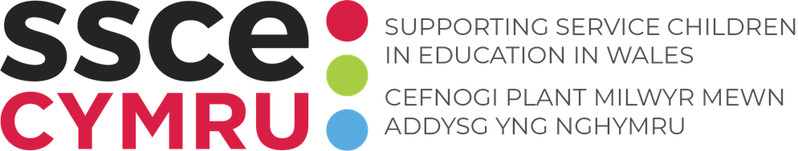

**TEMPLATE: Support for Service children**

School's provide amazing support for Service children across Wales. Include information on your offer to Service children on a dedicated page on your school's website.

**How to use this tool:**

Use the relevant text/sections of text within this template to support you in populating your school’s website page. A list of documents you may also find useful in attaching or referencing can also be found at the end of this tool.

**Instructions:**

1. Identify which sections of text you wish to use on your school website.
2. Edit the text where identified in red italics.
3. Create a page on your school’s website called 'Supporting Service children'.
4. Copy and paste onto your school’s website page.

**Support for Service children**

*(add school name)* is committed to supporting all pupils including our Service children.

**Definition of a Service child**

Welsh Governments definition of a Service child:  
 *A ‘Service child’ has parent(s) or person(s) exercising parental responsibility who is/are Service personnel serving:*  
 *- In HM Regular or Reserve Armed Forces – Royal Navy and Royal Marines; British Army and Royal Air Force, Or*  
 *- Is an Armed Forces Veteran who has been in Service within the past two years, Or*  
 *- One of their parents died whilst serving in the Armed Forces and the learner has received a pension under the Armed Forces Compensation Scheme or the War Pensions Scheme.*

We also identify Service children and young people who don't fit within the above definition but have a link to the Armed Forces.

**Experiences of a Service child**

Service children have a diverse range of strengths and experiences due to the unique circumstances they experience. Being part of a Service family can be extremely rewarding experience, but aspects of the Armed Forces lifestyle can have challenges that impact on a child’s education. Examples include;

* Frequent home and school moves
* Adverse Childhood Experiences (ACESs)
* Trouble managing emotions
* Gaps in curriculum knowledge / different curriculums e.g. England and Wales
* Settling in and joining activities
* School staff having limited knowledge of needs and challenges e.g. ALN
* Making and maintaining effective social networks e.g. friends, family
* Changing family dynamics
* Experiencing different cultures
* Learning new languages e.g. Welsh.

**School ethos**

At *(add school name*) we provide support and advice to ensure that Service children are provided with every opportunity to achieve the best possible outcomes and fulfil their potential. We aim for Service children to receive their full entitlement to statutory services and support and suffer no disadvantage due to their parent’s service commitments; this is the underpinning principle of the Armed Forces Covenant (see our school’s commitment to this *here*). We aim to provide support that is proactive and preventative as well as being responsive to emerging needs.

**How we support Service children**

It is important that we listen to Service children themselves to learn about their experiences and find out what support they need and what opportunities that would like.

At *(add school name)* we *(add information on your Service children offer e.g.*

* *Service children club - how, when, where the club meets*​
* *In school activities* ​
* *Extra-curricular activities* ​
* *Events e.g. Remembrance, Month of the military child, Armed Forces Day.*
* *Engagement with Armed Forces community*

*Consider adding images to evidence these activities and/or links to relevant SSCE Cymru journal entries and club page).*

**Service Children School Champion**

For any queries regarding Service children or the support please contact:

*(Enter the following details as appropriate)*

**Name:**

**Job title:**

**Phone number:**

**Email:**

**Armed Forces Friendly Schools Cymru status**

Through our work with SSCE Cymru we have achieved our *(Bronze/Silver/Gold)* [Armed Forces Friendly Schools (AFFS) Cymru](https://sscecymru.co.uk/en/schools-las/armed-forces-friendly-schools-cymru/) status.

The objectives of the AFFS are to embed good practice for supporting Service children, create a positive environment for Service children to share their experiences and encourage schools to become more engaged with their Armed Forces community.​

*(Add logo/s and certificate/s. Add your schools Armed Forces Friendly Schools Cymru status story and details of how you’ve celebrated your achievements. Consider linking to the SSCE Cymru journal entry.)*

**SSCE Cymru**

The SSCE Cymru mission is to provide the best possible educational support to Service children in Wales. The programme works with schools and local authorities across Wales to embed provision to best support children whose parent/s currently or have previously served in the Armed Forces. ​You can find more information about SSCE Cymru here.

**​**

**Useful documents and links**

[SSCE Cymru Service Family Guide](https://sscecymru.co.uk/media/cf1bja1b/ssce-cymru-service-family-guide-e.pdf)

[SSCE Cymru monthly school bulletin](https://sscecymru.co.uk/en/about-ssce-cymru/monthly-school-bulletin/)

[Little Troopers at Home](https://www.littletroopers.net/little-troopers-at-home/)

[MOD Education Advisory Team (EAT)](https://www.gov.uk/government/groups/defence-children-services-dcs)

.