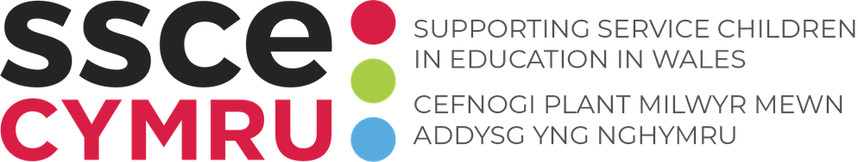

**TEMPLATE: Armed Forces Covenant school agreement**

Show your schools commitment to the Armed Forces Covenant; the promise from the nation to those who serve or have served, and their families which ensures that they are treated fairly and not disadvantaged in their day-to-day lives.

**How to use this tool:**

This template allows your school to demonstrate its commitment to the Armed Forces Covenant. Edit and link a copy of the template to your school's website.

**Instructions:**

1. Add your school’s name and logo where indicated.
2. Save a copy of the template.
3. Upload to the relevant page e.g. Service children page of the website.

|  |  |
| --- | --- |
| C:\Users\110468.PCC\AppData\Local\Microsoft\Windows\INetCache\Content.MSO\C408AC7B.tmp | *Add school logo here* |

The Armed Forces Covenant is a promise by the nation, ensuring that those who serve or who have served in the Armed Forces, and their families, are treated fairly.

The covenant focuses on helping members of the Armed Forces community, experience neither advantage nor disadvantage due to Service and therefore have the same access to government and commercial services and products as any other citizen.

For more information on the Armed Forces Covenant, visit:

[About Armed Forces Covenant](https://www.armedforcescovenant.gov.uk/about-the-covenant/)

[Armed Forces Covenant Duty Statutory Guidance](https://www.gov.uk/government/publications/armed-forces-covenant-duty-statutory-guidance)

At *(enter school name)* we demonstrate our commitment to the Armed Forces Covenant through the following activities:

* We engage with our Armed Forces community
* We celebrate the commitments of our Armed Forces community
* We create opportunities for our Service families to share their experiences
* We identify our Service children and ensure they are well supported in education
* We are proactive in gaining information that will enable us to support our Service children
* We engage with [SSCE Cymru](https://www.sscecymru.co.uk/) and the resources and support that they provide this includes training on the experiences and needs of Service children
* We ensure all our pupils have opportunities to learn about the current Armed Forces operations and commitments of the UK Service personnel
* We understand the commitments and sacrifices that our Armed Forces families make in ensuring we can be safe and protected from danger.

We demonstrate our commitment to supporting Service children through working towards/achieving our [Armed Forces Friendly Schools Cymru status](https://sscecymru.co.uk/en/schools-las/armed-forces-friendly-schools-cymru/).